**SQL RETAIL SALES PROJECT**

**PROJECT TITLE: RETAIL SALES ANALYSIS**

**PROJECT OVERVIEW**

This project is designed to demonstrate SQL skills and techniques typically used by data analysts to explore, clean, and analyze retail sales data. The project involves setting up a retail sales database, performing exploratory data analysis (EDA), and answering specific business questions through SQL queries.

OBJECTIVES

1. **Set up a retail sales database**: Create and populate a retail sales database with the provided sales data.
2. **Data Cleaning**: Identify and remove any records with missing or null values.
3. **Exploratory Data Analysis (EDA)**: Perform basic exploratory data analysis to understand the dataset.
4. **Business Analysis**: Use SQL to answer specific business questions and derive insights from the sales data.

PROJECT STRUCTURE

1. DATABASE SETUP

**Database Creation**: The project starts by creating a database named ‘RetailDB’

**Table Creation**: A table named retail_sales is created to store the sales data.

CREATE DATABASE RetailDB;

USE RetailDB;

--Create TABLE

CREATE TABLE retail_sales

(

transaction_id INT PRIMARY KEY,

sale_date DATE,

sale_time TIME,

customer_id INT,

gender VARCHAR(15),

age INT,

category VARCHAR(15),

quantity INT,

price_per_unit FLOAT,

cogs FLOAT,

total_sale FLOAT

);

**2. Data Exploration & Cleaning**

* **Record Count**: Determine the total number of records in the dataset.
* **Customer Count**: Find out how many unique customers are in the dataset.
* **Category Count**: Identify all unique product categories in the dataset.
* **Null Value Check**: Check for any null values in the dataset and delete records with missing data.

SELECT * FROM retail_sales

LIMIT 10;

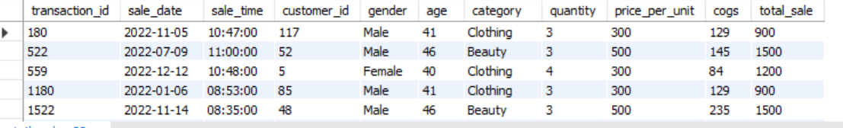

-- How many sales we have?

SELECT COUNT(*) AS total_sale

FROM retail_sales;

-- How many unique customers we have ?

SELECT COUNT(DISTINCT customer_id) AS Distinct_total_sale

FROM retail_sales;

-- How many uniuque categories we have ?

SELECT DISTINCT category

FROM retail_sales;

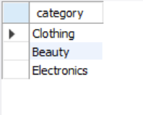

SELECT * FROM retail_sales

WHERE

sale_date IS NULL OR sale_time IS NULL OR customer_id IS NULL OR

gender IS NULL OR age IS NULL OR category IS NULL OR

quantity IS NULL OR price_per_unit IS NULL OR cogs IS NULL;

Alter Table retail_sales

Rename column ï»¿transactions_id to transaction_id;

Alter Table retail_sales

Rename column quantiy to quantity;

**Data Analysis & Findings**

The following SQL queries were developed to answer specific business questions:

-- Q.1 Write a SQL query to retrieve all columns for sales made on '2022-11-05

SELECT *

FROM retail_sales

WHERE sale_date = '2022-11-05';

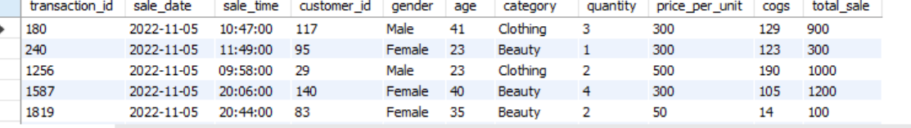

-- Q.2 Write a SQL query to retrieve all transactions where the category is 'Clothing' and the quantity sold is more than 4 in the month of Nov-2022

SELECT *

FROM retail_sales

WHERE

category = 'Clothing'

AND DATE_FORMAT(sale_date, '%Y-%m') = '2022-11'

AND quantity >= 4;

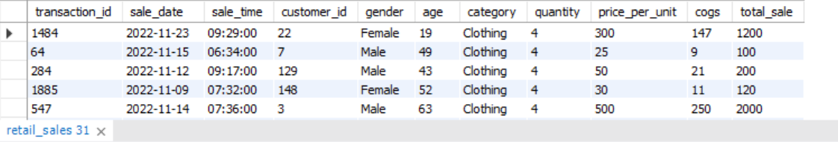

-- Q.3 Write a SQL query to calculate the total sales (total_sale) for each category.

SELECT

category,

SUM(total_sale) as net_sale

FROM retail_sales

GROUP BY category;

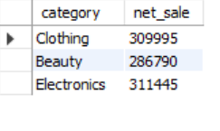

-- Q.4 Write a SQL query to find the average age of customers who purchased items from the 'Beauty' category.

SELECT

ROUND(AVG(age), 2) as avg_age

FROM retail_sales

WHERE category = 'Beauty';

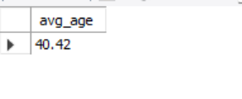

-- Q.5 Write a SQL query to find all transactions where the total_sale is greater than 1000.

SELECT * FROM retail_sales

WHERE total_sale > 1000;

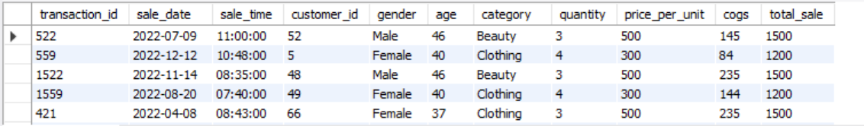

-- Q.6 Write a SQL query to find the total number of transactions (transaction_id) made by each gender in each category.

SELECT

category,

gender,

COUNT(*) as total_trans

FROM retail_sales

GROUP

BY

category,

gender

ORDER BY 1;

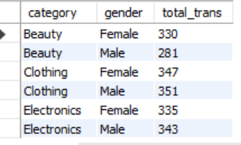

-- Q.7 Write a SQL query to calculate the average sale for each month. Find out best selling month in each year

SELECT

year,

month,

avg_sale

FROM

(

SELECT

EXTRACT(YEAR FROM sale_date) as year,

EXTRACT(MONTH FROM sale_date) as month,

AVG(total_sale) as avg_sale,

RANK() OVER(PARTITION BY EXTRACT(YEAR FROM sale_date) ORDER BY AVG(total_sale) DESC) as ranks

FROM retail_sales

GROUP BY 1, 2

) as t1;

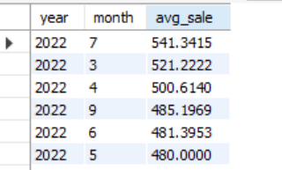

SELECT

year,

month,

avg_sale

FROM

(

SELECT

EXTRACT(YEAR FROM sale_date) as year,

EXTRACT(MONTH FROM sale_date) as month,

AVG(total_sale) as avg_sale,

RANK() OVER(PARTITION BY EXTRACT(YEAR FROM sale_date) ORDER BY AVG(total_sale) DESC) as ranks

FROM retail_sales

GROUP BY 1, 2

) as t1

WHERE ranks = 1

ORDER BY 1, 3 DESC;

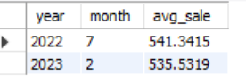

-- Q.8 Write a SQL query to find the top 5 customers based on the highest total sales

SELECT

customer_id,

SUM(total_sale) as total_sales

FROM retail_sales

GROUP BY 1

ORDER BY 2 DESC

LIMIT 5;

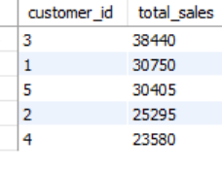

-- Q.9 Write a SQL query to find the number of unique customers who purchased items from each category.

SELECT

category,

COUNT(DISTINCT customer_id) as cnt_unique_cs

FROM retail_sales

GROUP BY category;

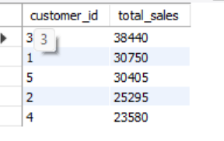

-- Q.10 Write a SQL query to create each shift and number of orders (Example Morning <12, Afternoon Between 12 & 17, Evening >17)

WITH hourly_sale

AS

(

SELECT *,

CASE

WHEN EXTRACT(HOUR FROM sale_time) < 12 THEN 'Morning'

WHEN EXTRACT(HOUR FROM sale_time) BETWEEN 12 AND 17 THEN 'Afternoon'

ELSE 'Evening'

END as shift

FROM retail_sales

)

SELECT

shift,

COUNT(*) as total_orders

FROM hourly_sale

GROUP BY shift;

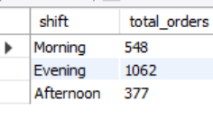

**Findings**

* **Customer Demographics**: The dataset includes customers from various age groups, with sales distributed across different categories such as Clothing and Beauty.
* **High-Value Transactions**: Several transactions had a total sale amount greater than 1000, indicating premium purchases.
* **Sales Trends**: Monthly analysis shows variations in sales, helping identify peak seasons.
* **Customer Insights**: The analysis identifies the top-spending customers and the most popular product categories.

**Reports**

* **Sales Summary**: A detailed report summarizing total sales, customer demographics, and category performance.
* **Trend Analysis**: Insights into sales trends across different months and shifts.
* **Customer Insights**: Reports on top customers and unique customer counts per category.